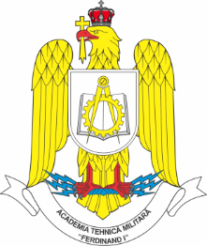 | MILITARY TECHNICAL ACADEMY  “Ferdinand I”  Bucharest | 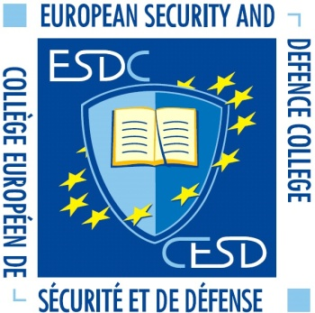
APPLICATION FORM
Student/staff mobility
Remarks:  - Please fill in the yellow & blue fields only.  - Fill in 1 form for 1 person.  - Click into squares to mark, click again to unmark.  - When concluded, send this form to:  erasmus@mta.ro | I want to participate in the event  (please fill in the name of the event below)
STUDENTS’ INTERNATIONAL CONFERENCE “CERC” 2025
10.04.2025 – 13.04.2025

Male | Female | Rank | Family name | First name
☐ | ☐

Date of birth | Nationality | Passport number | Passport validity until

Branch of Service  (if available) | Sending institution’s name | I want to participate as ….  (click to mark)
 |  | Student | Staff | Military | Civilian
 |  | ☐ | ☐ | ☐ | ☐

Phone number (if available) | Mobile number (if available) | e-mail address

Point of contact (POC) of sending institute
Male | Female | Rank | Family name |  | First name
POC’s phone number |  |  |  | POC’s e-mail address

Point of contact (POC) of receiving institute (MTA)
Male | Female | Rank | Family name |  | First name
x |  | COL(AF) | MOLDOVEANU |  | Cristian-Emil
POC’s phone number |  |  |  | POC’s e-mail address
+40721288312 |  |  |  | cristian.moldoveanu@mta.ro

Arrival date in Bucharest | Arrival time in Bucharest | By plane | By train | By car | By bus | Need local transport to the MTA location
 |  |  |  |  |  | Yes | No

Departure date from Bucharest | Departure time from Bucharest | By plane | By train | By car | By bus | Need local transport to the MTA location
 |  |  |  |  |  | Yes | No

Do you need accommodation (only for students/cadets)? | Yes | No
Special dietary or food requirements due to medical or religious reasons  (click to mark) |  | If yes, please specify food you cannot eat
No | Yes
 | ☐

Additional remarks  (need for special equipment, special travel arrangements, etc.) | Insert below your picture  (preferably a passport picture in jpg-format or attach the picture to the mail)

Please integrate your passport/ID hereinafter:

Please send the application form to erasmus@mta.ro

Data protection:
Your data will be used for necessary internal administrative procedures only.
They will not be published in any case!

